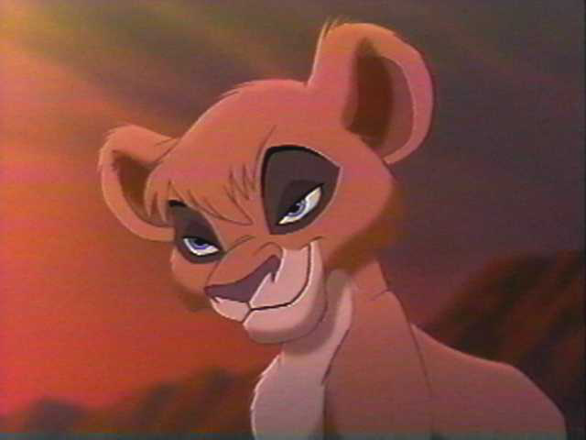 Based on The Lion King II: Simba’s Pride
By Julia Rubin

It was cold in the den as I closed my eyes and brushed my paw against my hair bangs. I saw mother sleeping next to Tanabi, her sister, and Kovu by their side. Nuka, as usual was sleeping in a dirty termite infested corner all by himself. After my father Scar left home, things seemed lonely. He had gone off to war to fight for his place as king. Now, he is dead. I still remember the day he left. It was cold and rainy. As he started to leave, he told me how beautiful I looked, and told mother to make Kovu his heir. Mother thought he was the most wonderful lion she’d ever met. Now, it is different.
I awoke to the sound of obnoxious snoring. Mother was licking Kovu. He snores like a thunderstorm sometimes. Aunt Tanabi was playing with her friend Zella, another Outsider.
We are all Outsiders, because of king Simba. He banished Scar’s followers here, including me and my family.
I saw Nuka yawn, stretch, and hobble over to his sunning rock. “Vitani!” mother called. I hopped over to her . “There’s something you need to do. Go over to Simba’s lands. From my rock, I’ve seen animals coming from all over to seek that point. Please go investigate.” I purred and rubbed across her legs. She smiled and gave me a rough and playful nudge in the ribs. Then she turned to Nuka. “Go watch her.” She commanded. “Make sure nothing happens to her. Go, now!”
Nuka grumbled and followed me. “Boy Nuka,” I said. “ Are we going to have fun!” Nuka growled.
By the time we made it to the Pride Lands, my paws were sore and Nuka was complaining up a storm. “Now,” he commanded, scratching his left ear “You go your way and I’ll stay here.” Then we split up. How fun it was to romp and roll in the fresh dirt, far better than the dry soil at home.
Soon, I found the perfect tree and climbed it. What a view! Laying on a limb I saw Nuka scrambling out of a herd of Zebra. I then turned my attention to Pride Rock. On it, King Simba and Queen Nala were watching as a baboon dude holds a baby lion up for all the animals to see. A baby!
I was so excited I jumped up, forgetting I was on a tree limb, and heard a crrrack! At that moment I fell and landed with a thud on the ground. I opened my eyes and came face-to-face with…. Tanabi! “Now what in the world are you doing!?” shouted Tanabi. “Um, watching the ceremony.” I said sheepishly. Tanabi scowled. “Where’s Nuka?” I didn’t speak. I didn’t know.
Then we heard a “YELP!!” It was Nuka allright. A Zebra had stepped on his tail. When I turned around again, Tanabi was gone.
As I climbed the tree once more, I saw the baboon dude say, “It is a girl.” I whooped and scurried down the tree in excitement. Running quickly, I soon caught up with Nuka.
“Oh no. Yeech!” I cried. “Double Yeech!” Nuka said. I grabbed his tail with my teeth and dug in hard. Nuka yelped a pushed me back.
Injured and exhausted I said, “ Nuka, last one to tell mother loses. So,” I started running as I spoke, “Catch ya in the losing column! Toddles!” and I raced off.

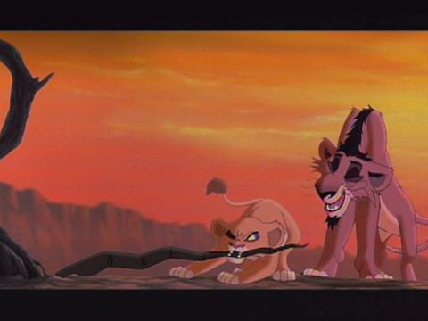Me and Nuka

As Nuka and I caught up near the Outlands, we both rushed and shoved to be the first to tell mother about our adventure.
“Mother mother mother!” we cried. “We were there… in the Pride Lands,” Nuka began. “At Pride Rock, we saw everything!” I shouted as I scurried through Nuka’s legs. “We saw the whole thing!” Then at once we said, “ We saw Simba’s cub!” Mother looked shocked. “Vitani, what did you see?” she asked. “Simba’s new cub is a girl!” I cried. “A girl?!” laughed mother. “Scar my beloved, did you hear that? This couldn’t be more perfect.” Nuka frowned. ”Who’s she talking to?” he asked. I rolled my eyes. “Shhh! Scar.” Nuka gasped. “Where, where?!”
I sighed at my bother’s hopelessness. “Scar’s dead genius.” I informed him.
“Yes.” Agreed mother. “It’s because of Simba! If not for him, Scar would still be king, and I Zira, his long loving devoted queen.”
“You know,” Nuka began “Speaking of kings, I was thinking, MAYBE I SHOULD BE KING, UH?” Mother pounced on him and yelled, “ Don’t be a fool Nuka!” Nuka laughed sheepishly and said, “Uh, just a thought.” Mother slowly unaccended him and said, “ We must fulfill Scar’s dying wish, and train Kovu to become king.” “Oh yeah!” cried Nuka. “I can do that!”
Mother jumped on her perch with Tanabi. Nuka and I followed. “Look at the Pride Lands my pets.” Tanabi said. “So green and inviting.” Mother sighed. “And soon my beloved Scar, we shall reclaim your kingdom.”
Seasons passed. Nuka and I grew into older, stronger and smarter cubs. One day, mother said to Nuka as she started out for a walk, “Watch Kovu. If anything happens, get me. I’ll be at the waterhole,” Then she turned away. Nuka groaned. I knew he hated watching Kovu. Kovu pounced on Nuka. “Wanna play?” he snarled. Nuka pushed him off. “Oh, go do something on your own. I need a break.” Then he slunk off. I ran up to him and tagged him. “Nuka!” I shouted. “Watch Kovu. He gets into mischief too much.” Then, I sighed, shook off the dust in my fur and strolled around the Outlands. Soon, I came across Tanabi and her husband Alubi.
“Hey aunt bi!” I shouted happily. Tanabi smiled and said, “Hey Tani. Anything new?”
“No.” Then I pulled her ear. “You know,” said Tanabi, “I heard a great way to keep your teeth clean is to chew on something soft.
“Great idea!” I said, and searched the land for something to chew. Then, I saw it. My dream stick. I spent all day chewing it and trying to pull it out off the dead tree so I could chew it everywhere. Only, I couldn’t. Then, I heard a mumble from behind and saw Nuka! “Oh hey Vitani.” he said. “Where’s little termite Kovu, the chosen one?” Then he took his claw and snapped the branch off the tree I was chewing on. I fell back and scrambled to my feet when I noticed Kovu was gone!
“Nuka!” I gasped. “Where’s Kovu? Did you leave him out there on his own again?” Nuka started scratching and said, “Hey, it’s every lion for himself out here and that little termite’s gotta learn to be on his own.” I snarled, “Mother’s gonna be mad! She told you to watch him!”
“Oh, who cares!” shouted Nuka, continuing to scratch, “I should have been the chosen one. After all, I’m the oldest, the strongest, the smartest,” Then he jumped up, scratching wildly and moaned, “Oh these termites!” Then he bit himself everywhere and shrieked.
Feeling self-satisfied, I smiled slyly. “I could be a leader if she’d just give me a chance!” protested Nuka. “Yeah right.” I jeered and then said, “Well why don’t you tell that to her?” Nuka scowled and said, “Yeah, don’t think I won’t!”
“Oh yeah,” I said with a bit of a chuckle, “Here’s your chance.” Suddenly Nuka realized mother was back…with Kovu. “Mother, hi!” shouted Nuka, trying to get attention, “Mother, I caught some field mice for you’re dinner and I left em by the,” realizing he wasn’t getting attention he said, “Um, O.K.”
“Hey Kovu!” I said when mother put him down. “Wanna fight? Rar rar!” Then mother turned to Nuka, “You were supposed to be watching him!”
Tired of all the commotion, I slunk away. In my freedom, I came across Tanabi. “Hey,” she said. “What’s new?” I yawned. “Same old same old.” Then I went into the cave. Kovu was in his stump bed.
There, mother said, “I now see the path to our glorious return to power.” The Outsiders growled. “But I don’t want,” Kovu started. “Hush!” Zira interrupted. “Hush, my little one. You must be exhausted.”
Then she sang, “Sleep my little Kovu, let you’re dreams take wing, one day when you’re big and strong, you will be a king.” “Goodnight.” Said Kovu. “Goodnight my little prince,” Mother said. “Tomorrow you’re training intensifies.”

Song: My Lullaby
Zira and Tanabi: We’ve been exiled, persecuted,
Left alone with no defense
When we think of what that brute did
We get a little tense
Zira: But I dream a dream so pretty
That I don’t feel so depressed
‘Cause it sooths my inner kitty
And it helps me get some rest
The sound of Simba’s dying gasp!
Nuka: (groans and pretends to collapse )
Zira: His daughter squealing in my grasp!
Vitani: (moans and struggles out of Nuka’s reach)
Zira: His lioness’s mournful cry!
(Tanabi’s shadow is visible behind Zira and she groans)
Zira: That’s my lullaby!
Zira and Tanabi: Now the past we’ve tried forgetting
And our foes we could forgive
Zira: Trouble is I know it’s petty
Tanabi: But we hate to let them live!
Nuka: So you’ve found yourself somebody
Who’ll chase Simba up a tree
Tanabi: Oh the battle may be bloody
Zira: But that kinda works for me
(She pushes Nuka off the rock and he yells)
Zira: The melody of angry growls
(The outsiders roar)
Tanabi: A counterpoint of painful howls!
(She steps on Nuka’s tail and he yelps)
Tanabi: A symphony of death, Oh my!
Zira: That’s my lullaby
Scar is gone, but we are still around
To love this little lad
(She licks Kovu who is asleep)
Tanabi: ‘Till he learns to be a killer
Tanabi and Zira: With a lust for being bad!
(Screen moves toward Kovu’s stump bed, in which he and Vitani are in. Kovu’s asleep. Nuka is beside the bed with his front paws on)
Nuka: Sleep ya little termite!
(He sees Vitani’s scowl)
Nuka: (sarcastically) Oh, I mean precis little thing!
(Vitani swats him off the bedside)
Vitani: (tucking in Kovu) One day when you’re big and strong!
Zira: You will be a king!
(Outsiders jump over Kovu’s bed as he sleeps)
Zira: The pounding of the drums of war!
Tanabi: Da thrill ah Kovu’s mighty roar!
Nuka: The joy of benjence!
Vitani: Testify!
Tanabi: I can hear the cheerin’
Nuka and Vitani: Kovu, what a guy!
Tanabi: Payback time is nearing
Zira: And then our flag will fly!
Both: Against a blood red sky!
Zira/Chorus/Tanabi: THAT’S MY LULLABY!
SONG ENDS

